**REPORT**

**Price Comparison Tool**

**Group Members**:

|  |  |  |  |
| --- | --- | --- | --- |
| Sr. No. | PRN | Name | Mail id |
| 1 | 22070122254 | Yash Bhisekar | yash.bhisekar.btech2022@sitpune.edu.in |
| 2 | 22070122263 | Atharva Sawant | Atharva.sawant.btech2022@sitpune.edu.in |
| 3 | 22070122238 | Tshewang Rinzin | tshewang.rinzin.btech2022@sitpune.edu.in |

**Problem Statement**:

Consumers often face the difficult task of comparing costs for various goods and services among numerous online and offline merchants in today's highly competitive and dynamic industry. This process takes a long time, is difficult, and usually results in poor purchasing choices. Additionally, it is difficult for customers to make smart choices due to the everchanging prices.

Explanation:

In order to address a common problem experienced by customers in today's diversified and competing marketplace, the Price Comparison Tool (PCT) project developed a software-based solution. The difficulty and time-consuming nature of comparing pricing for goods and services among numerous vendors in the online domain is the issue it tries to address.

The primary objectives of the project is to make price comparison easier and provide consumers with more control over what they purchase.

Class Diagram:

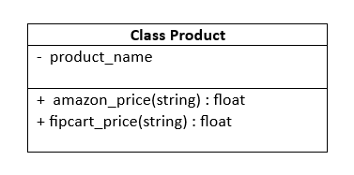

Code Snippets:

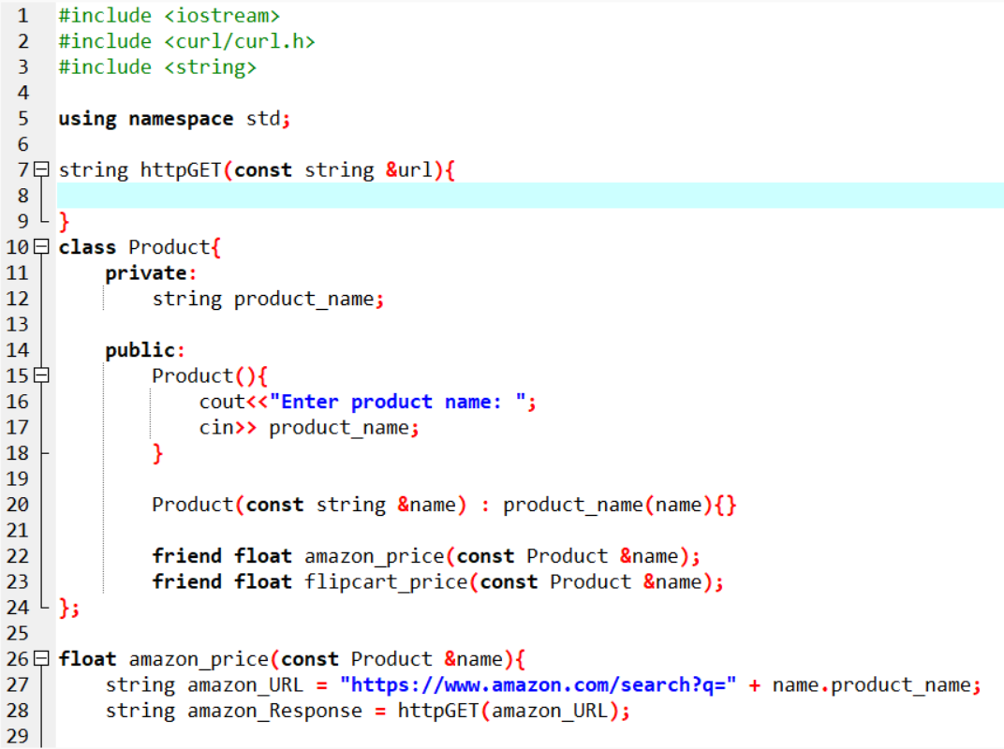

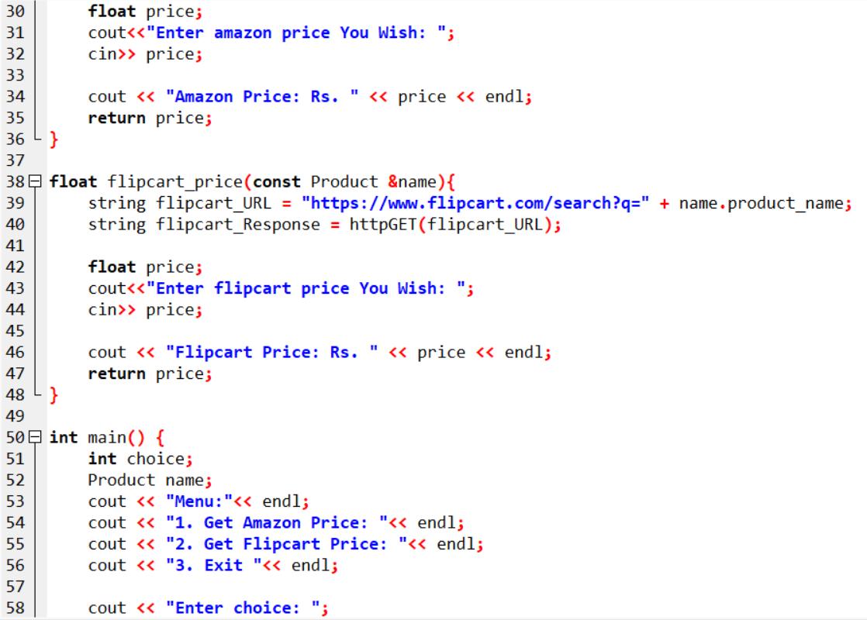

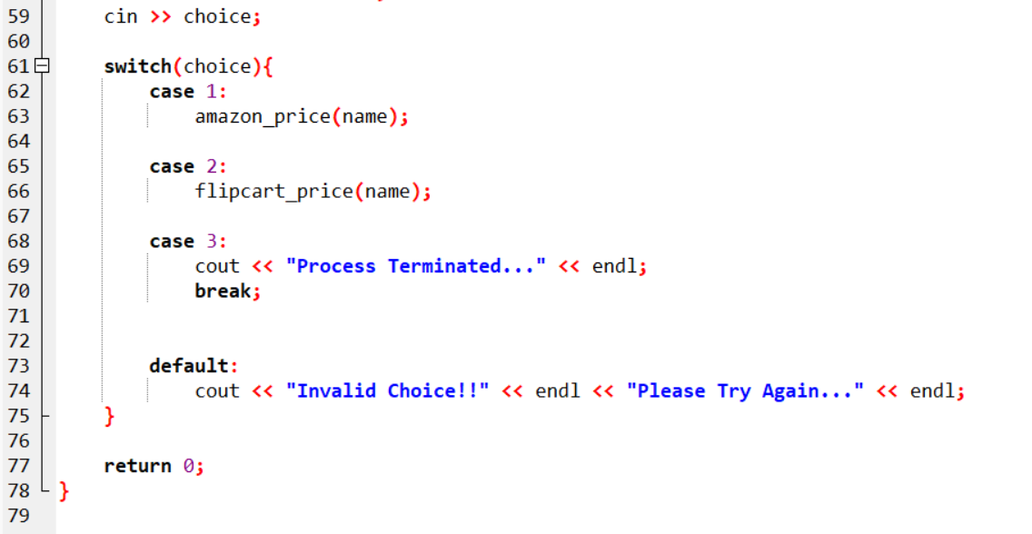

Input/Output:

